Puppet People – Small Puppet Pattern
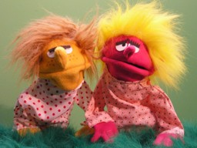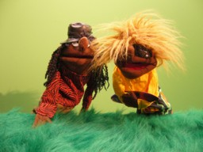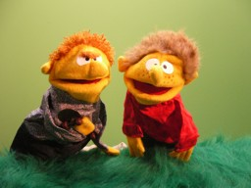

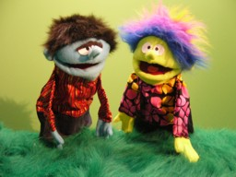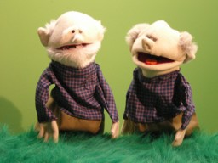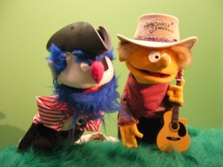

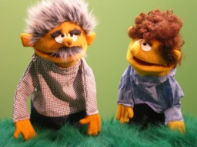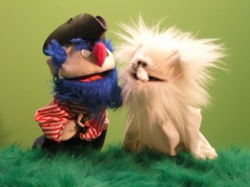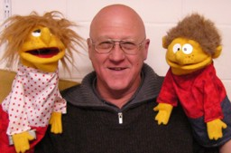

Pattern developed by;

Dan Martin,
Puppet Vision Trust,
43 Hampton Tce. Parkvale,
Tauranga, New Zealand

Phone 07 577 0240, Mobile 027 276 5162
Email dan@puppetvision.co.nz
www.puppetvision.co.nz

Guidelines to be used with “Puppet People” Puppet Pattern.

Materials needed: Recommended equipment:
Polar fleece for faces and hands. | Sewing Machine (pref. independent arm)
Two other fabrics for shirt and skirt. | Good scissors.
Red, black or pink fabric for inside of mouth. | Sharp craft knife.
10 – 15mm foam for head stiffener. | Hot glue gun.
Fur fabric for hair. | Contact adhesive.
Iron on interfacing for neck and sleeves.
Fabric tape for mouth.
Puppet eyes – there are many options.
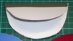  Cut 2 mouth stiffener pieces out of plastic. Ice cream containers are perfect. Place them one on top of the other (closed mouth), and tape them with fabric tape providing a hinge.  Open the mouth pieces out and glue to the fabric that you have chosen for the inside of the mouth. | 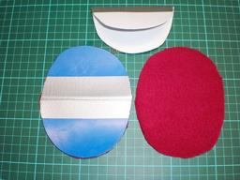
Now prepare the foam for the inside of the head. Cut two pieces of foam from the pattern and apply glue to the edges indicated.  You can use contact adhesive or hot glue to put the pieces together. | 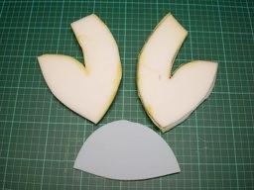
Assemble the head foam pieces to form a dome shape that will give the puppet head a good shape.  The mouth lining piece will be glued to the top of the mouth on assembly to hold your hand in place while operating the puppet. It provides better control. | 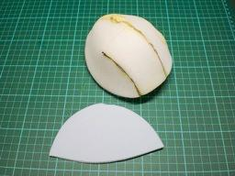
Cut out 2 shirts.  Stitch good sides together from cuff to neck on both sides and from cuff to waist. Do not sew the neck or waist openings together.  It’s a good idea to double stitch the angle at the neck and shoulder as that takes quite a strain when the arms move around | 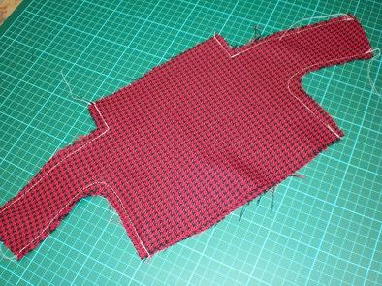
Cut out skirt and stitch into a tube.  When assembling the dress (shirt and skirt) it’s a good idea to place the seam at the back so that the skirt looks like a continuous item.  Of course if you wanted the boy’s trousers to have a “fly”, you could put the seam at the front. | 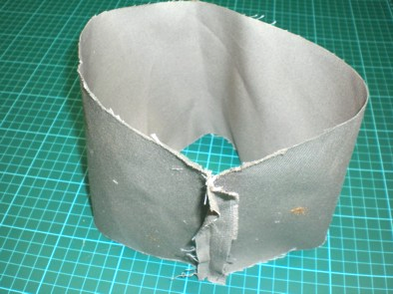
Stitch dress top to bottom at belt line.  Run two lots of stitching around the waist to give it extra strength.  If you have an over locker, or a zig zag facility on your sewing machine, it will give it extra strength and stop any fraying occurring. | 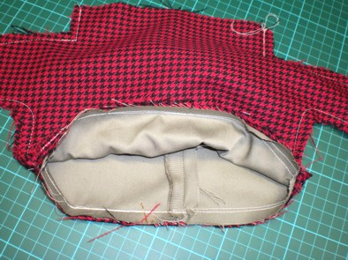
Hem the bottom of the skirt to tidy it up and stop fraying.  Iron interfacing to neck and sleeves. This will make the neck and sleeves much easier to shape with the final stitches. | 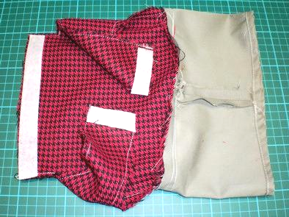
Trace the hands, nose and ears pattern onto the polar fleece. Stitch them while the fabric is still in one piece.  After stitching them together, cut out the individual hands, ears, noses, cut in half and turn right side out.  Run a stitch between the “fingers” to give the hands more character. Fold and stitch the nose in half length wise to give it more shape. | 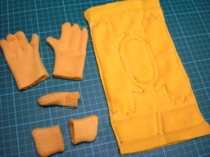
Cut out the hair. It’s always best to use a sharp craft knife to cut out fur fabric, and cut it from the back so that you don’t cut through the wispy “trails” that you want to retain for a fringe and give the hair that body.  Cut out face, gullet and neck pieces. | 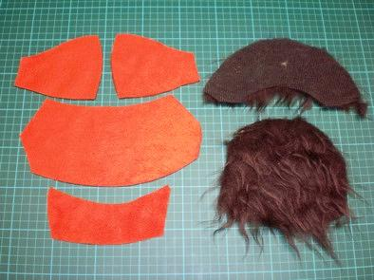  Face pieces  Gullet or chin  Neck
1 - Stitch the nose to one side of the face to baste it in place.  2 - Pin and stitch the two face pieces together. | 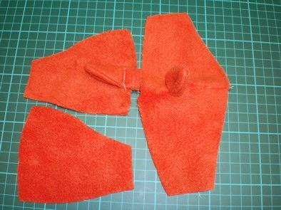  1  2
Pin and stitch the back hair to the neck piece. | 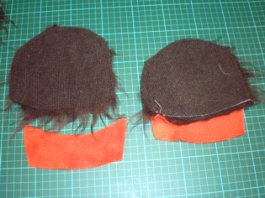
Pin and stitch the front hair to the face.  Remember always to stitch the good sides towards each other. The whole thing is going to be turned inside out in the end. | 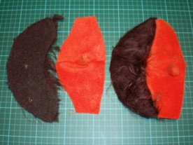
Stitch the gullet to sides of face. | 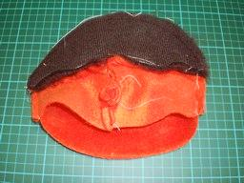  Gullet or chin  Face & hair front
Stitch ears to back of head at hair line to keep them in place when you sew face to back of head. | 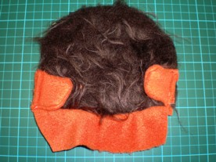  Neck & back of head
For girl’s hair, use long fur and hot glue two tubes of hair that can be inserted as pig tails, or pony tails. | 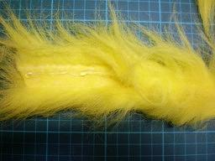
Sew the hair extensions in as pig or pony tails before sewing back of head to front hair and face. | 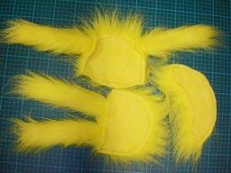
Pin and sew the face to the back of the head.  Where the face and hair front join, line the join up with the middle of the ear. This gives the front hair a “side board” effect. | 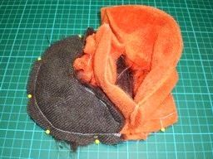
Pin the face to the mouth stiffener through the red fabric. You won’t be able to push the pins through the plastic stiffener, but the red material will give you something to pin to.  Stitch around the mouth 5 mm from the edge through the face and plastic.  Run two sets of stitches around the mouth to give it extra strength. | 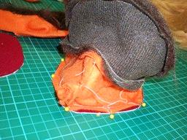
Glue mouth flap to top of inside mouth. This little flap will make a huge difference to the operation of your puppet.  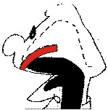  Without the mouth flap your fingers don’t have the control of the mouth movement that you have with it in. Though it is optional, it makes a big difference to controlling the movement of the mouth.  Mouth  flap | 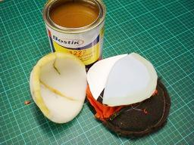  Mouth flap  Liner for  Inside of  head
Glue the head foam to the top of the mouth and mouth flap. | 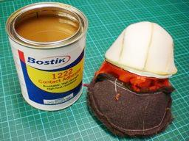
When your glue is dry, turn the head right side out. | 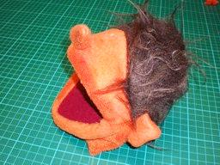
Insert hands up sleeves (thumbs up).  Stitch hands in sleeves along the middle of the interfacing – remember to put the thumbs up. | 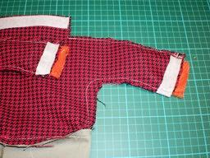
Stitch neck to dress – Head right side out, shirt still inside out. | 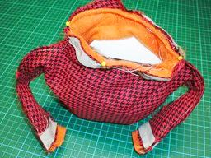
Turn the whole puppet body right side out and stitch the sleeves down. | 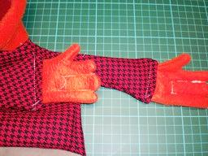
Run a final stitch around the neck to give the “polar neck” look so that the head appears to come out of the shirt, and not the other way around! | 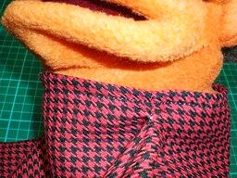
Now all you need is eyes, tongues, black at the back of the throat, or whatever other. Props you may with to add to give your puppet that unique character.

